**PIZZA SALES SQL QUERIES**

1. Total Revenue

select sum(total_price) as total_revenue from pizzaSales

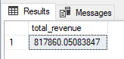

1. Average Order Value

select sum(total_price) / count(distinct order_id) Avg_Order_Value from pizzaSales

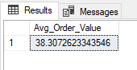

1. Total Pizza Sold

select sum(quantity) as Total_Pizza_Sold from pizzaSales

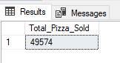

1. Total Orders

select count(distinct order_id) as Total_Orders from pizzaSales

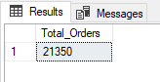

1. Average Pizzas per Order

select cast(cast(sum(quantity) as decimal(10,2)) /

cast(count(distinct order_id) as decimal(10,2)) as decimal(10,2))

as Avg_PizzasPerOrder from pizzaSales

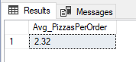

1. Daily Trends for Total Order

select datename(dw, order_date) as order_Day, count(distinct order_id) as Total_orders from pizzaSales group by datename(dw, order_date)

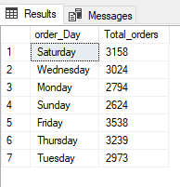

1. Hourly Trend for Total Orders

select DATEPART(hour,order_time) as Order_Hours, count(distinct order_id) as Total_Orders from pizzaSales group by DATEPART(hour,order_time) order by DATEPART(hour,order_time)

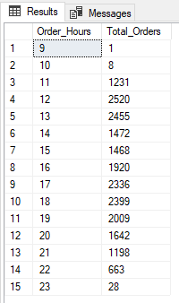

1. Percentage of Sales by Pizza Category

select pizza_category,sum(total_price) as Total_Sales, sum(total_price)*100/

(select sum(total_price) from pizzaSales) as PCT

from pizzaSales

group by pizza_category

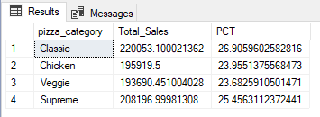

Note - Add where month(order_date) =1 to get data of first month i.e January

1. Percentage of Sales by Pizza Size

select pizza_size,sum(total_price) as Total_Sales, sum(total_price)*100/

(select sum(total_price) from pizzaSales) as PCT

from pizzaSales

group by pizza_size

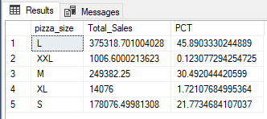

1. Total pizas sold by pizza category

select pizza_category, sum(quantity) as Total_Pizza_Sold from pizzaSales

group by pizza_category

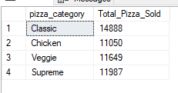

1. Top 5 best Sellers by Total Pizzas Sold

select top 5 pizza_name, sum(quantity) as Total_Pizza_Sold from pizzaSales

group by pizza_name

order by sum(quantity) desc

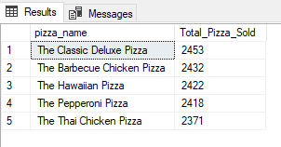

1. Top 5 worst Sellers by Total Pizzas Sold

select top 5 pizza_name, sum(quantity) as Total_Pizza_Sold from pizzaSales

group by pizza_name

order by sum(quantity)

